CONTACT MANAGER
PROJECT OVERVIEW:
A Contact Manager is a simple application used to store and manage contact information such as names, phone numbers, and email addresses. It allows users to easily add, view, update, search, and delete contacts.
TEAM LEADER:
1.BHAVANI.P
EMAIL ID:bhavaniprakash7777@gmail.com
TEAM MEMBERS:
2.HARUNIKA.S
EMAIL ID:harunikaselvam@gmail.com
3.DIVYA.K

EMAIL ID:karunanithidivya8@gmail.com

4.NANDHINI.K

EMAIL ID:n13060983@gmail.com
1.INTRODUCTION:
A Contact Manager is a software application used to store, organize, and manage contact information efficiently. It helps users save important details such as names, phone numbers, email addresses, and other personal information in a digital format. The main purpose of a contact manager is to make it easy to add, edit, search, and delete contacts whenever needed. This system reduces the difficulty of maintaining contacts manually and ensures quick access to information. Contact Manager applications are widely used in personal and professional environments to keep communication details well organized.

2.KEY OBJECTIVES:
- .Store Contact Information
  - Save details like name, phone number, email address, and address in a structured format.
- Add New Contacts
  - Allow users to easily add new contact details to the system.
- Edit Existing Contacts
  - Enable users to update or modify contact information when needed.
- Delete Contacts
  - Provide an option to remove unwanted or outdated contacts from the list.
- Search Contacts
  - Allow users to quickly find a contact using name or phone number.

- Organize Contact Data
  - Maintain contacts in an orderly way for easy access and management.
7.Improve Efficiency
Reduce the time and effort required to manage contact details manually.
PROJECT INSTRUCTION:
- Create a Contact Manager System
Develop a program that helps users manage contact details in an organized way.
- Add Contact Details
The system should allow users to add new contacts with information such as name, phone number, and email.
- Display Contact List
The program should show all saved contacts clearly for easy viewing.
- Edit Contact Information
Users should be able to update or modify existing contact details.
- Delete Contacts
The system should allow users to remove contacts that are no longer needed.
- Search Contacts
Provide an option to quickly search for a contact using the name or phone number.
- User-Friendly Interface
The system should be simple and easy to use so that users can manage contacts without difficulty.
PROJECT THUMBNAIL:
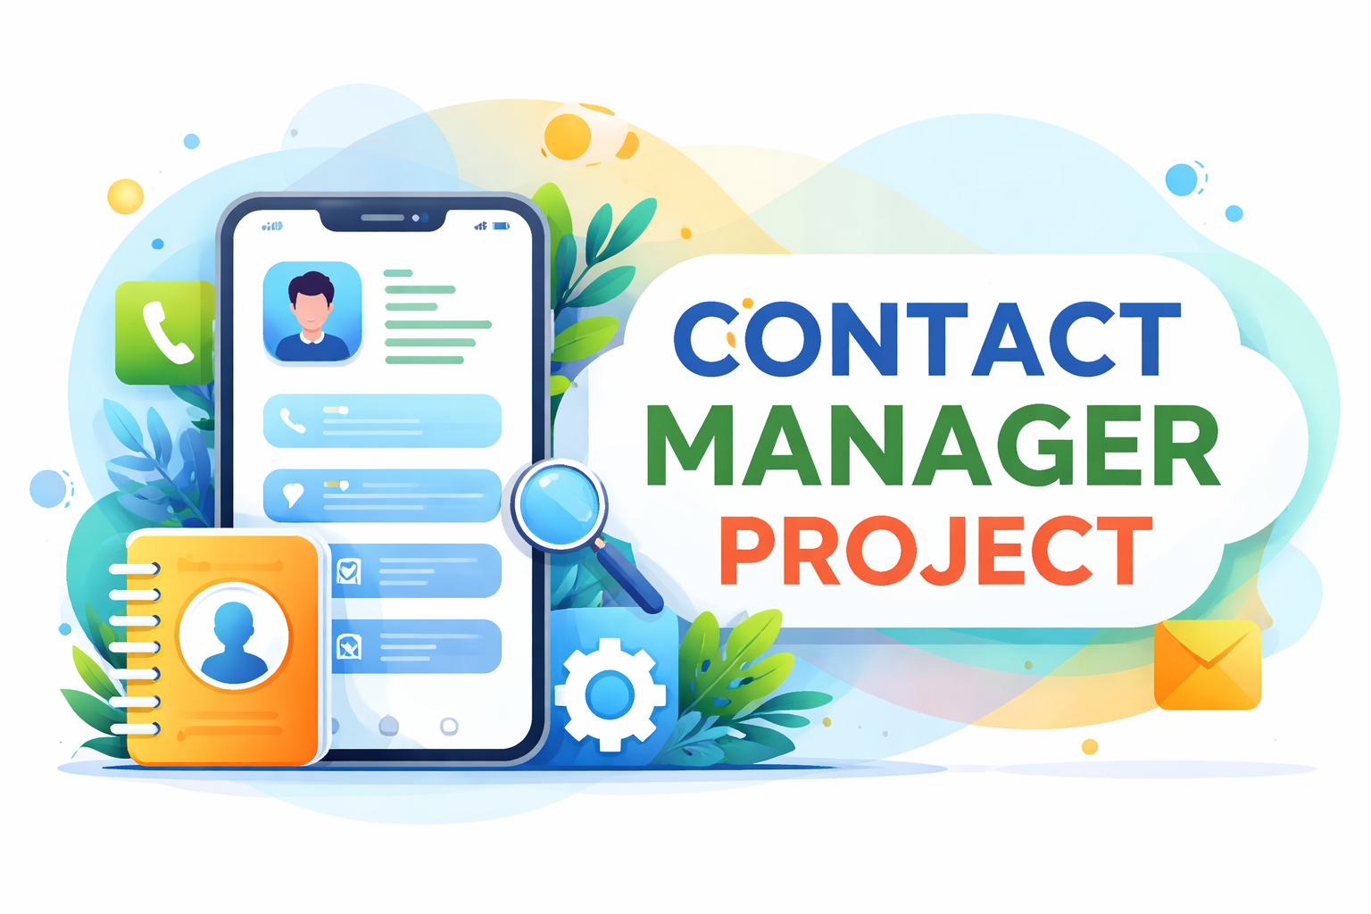

FEATURES:
1.Add Contact Module
This module allows users to add new contacts by entering details such as name, phone number, email, and address.
2.View Contact Module
This module displays all the saved contacts in a list so users can easily see their stored information.
3.Search Contact Module
It helps users quickly find a specific contact by searching with a name or phone number.
4.Edit Contact Module
This module allows users to update or modify existing contact details when there are changes.
5.Delete Contact Module
It provides an option to remove contacts that are no longer needed.
6.Save and Manage Data Module
This module ensures that all contact information is stored and managed properly in the system.

ROLES AND RESPONSIBILITY:
- Managing Contact Information
Store and maintain contact details such as name, phone number, email, and address.
- Adding New Contacts
Ensure new contacts are added accurately to the system.
- Updating Contact Details
Edit or update contact information when there are changes.
- Deleting Unnecessary Contacts
Remove outdated or duplicate contacts to keep the list organized.
- Searching and Retrieving Contacts
Quickly find and access contact information when needed.
- Organizing Contact Data Maintain contacts in a structured and easy-to-access format.
- Ensuring Data Accuracy
Check that all stored contact details are correct and up to date.
ProjectDocument:
https://drive.google.com/drive/folders/1NBTW_hFGEulZgZYnatwmWn73HohRai_U?usp=drive_link
Demo Video:

GitHub Link:
https://github.com/harunikaselvam2025/Contact-Manger.git

